Experiment- 9
Branch: MCA (AI&ML) | Semester: 2
Student Name: Ajay Rakwal | UID: 25MCI10329
Subject Name: Technical Training | Subject Code: 25CAP-652
Section/Group: MAM-1(A) | Date of Performance: 07-04-2026

Aim of the program:
To implement database triggers in PostgreSQL to automatically calculate values and enforce constraints during data insertion operations.

Software Requirements
- Operating System: Windows / Linux
- Database Management System: MySQL / Oracle / PostgreSQL
- SQL Interface: MySQL Workbench /Web Based / pgAdmin

Objective
- To understand the concept and working of database triggers in PostgreSQL.
- To learn how to automatically calculate derived values during data insertion.
- To implement BEFORE INSERT triggers for enforcing business rules.
- To apply constraints using trigger logic to validate data before insertion.
- To understand how triggers help maintain data integrity and automation in databases

Procedure of the Practical
- Open PostgreSQL (pgAdmin) and connect to the required database.
- Create the Employee table with fields such as emp_id, emp_name, working_hours, perhour_salary, and total_payable_amount.
- Write a trigger function using PL/pgSQL to calculate the total payable amount based on working hours and per-hour salary.
- Add validation logic inside the function to restrict insertion if the total payable amount exceeds the specified limit.
- Create a BEFORE INSERT trigger and associate it with the Employee table to execute the function automatically.
- Insert sample records into the Employee table to test the trigger functionality.
- Observe the behavior for valid and invalid inputs (accepted and rejected records).
- Retrieve and verify the inserted records using a SELECT query.

Practical / Experiment Steps
-- STEP 1: CREATE EMPLOYEE TABLE
CREATE TABLE employee (
emp_id INT PRIMARY KEY,
emp_name VARCHAR(50),
working_hours INT,
perhour_salary NUMERIC,
total_payable_amount NUMERIC);
-- STEP 2: CREATE TRIGGER FUNCTION TO CALCULATE PAYABLE AMOUNT
CREATE OR REPLACE FUNCTION CACULATE_PAYABLE_AMOUNT() RETURNS TRIGGER
AS
$$
BEGIN
-- CALCULATE TOTAL PAYABLE AMOUNT
NEW.total_payable_amount := NEW.perhour_salary * NEW.working_hours;
-- STEP 3: APPLY VALIDATION CONDITION (MAX LIMIT CHECK)
IF NEW.total_payable_amount > 25000 THEN
RAISE EXCEPTION 'INVALID ENTRY BEACUSE PAYABLE AMOUNT CAN NOT BE GREATER THAN 25000';
END IF;
-- RETURN UPDATED RECORD
RETURN NEW;
END;
$$ LANGUAGE PLPGSQL;
-- STEP 4: CREATE TRIGGER TO EXECUTE FUNCTION BEFORE INSERT
CREATE OR REPLACE TRIGGER AUTOMATED_PAYABLE_AMOUNT_CALCULATION
BEFORE INSERT
ON employee
FOR EACH ROW
EXECUTE FUNCTION CACULATE_PAYABLE_AMOUNT();
-- STEP 5: INSERT VALID RECORD (SHOULD BE ACCEPTED)
INSERT INTO EMPLOYEE (EMP_ID, EMP_NAME, working_hours, perhour_salary)
VALUES (1, 'Ajay', 15, 1000);
-- STEP 6: INSERT INVALID RECORD (SHOULD THROW ERROR)
INSERT INTO EMPLOYEE (EMP_ID, EMP_NAME, working_hours, perhour_salary)
VALUES (2, 'Purnima', 8, 100000);
-- STEP 7: DISPLAY FINAL TABLE DATA
SELECT * FROM EMPLOYEE;

I/O Analysis (Input / Output)
Input
- Table creation query for Employee
- Trigger function definition for calculating payable amount
- Trigger creation statement (BEFORE INSERT trigger)
- INSERT queries with employee details (working hours and per-hour salary)
Output
- Employee table created successfully
- Total payable amount automatically calculated during insertion
- Valid records inserted correctly into the table
- Invalid records (payable amount > 25000) rejected with an error message
- Data integrity maintained through trigger-based validation

OUTPUT:
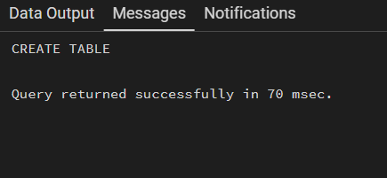
--Table Created:

--CREATE TRIGGER FUNCTION AND APPLY VALIDATION:
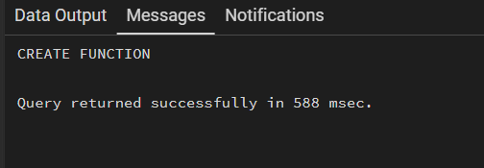

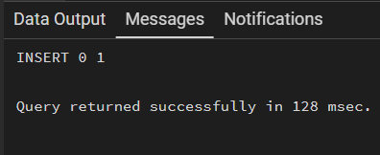
-- INSERT VALID RECORD (SHOULD BE ACCEPTED)

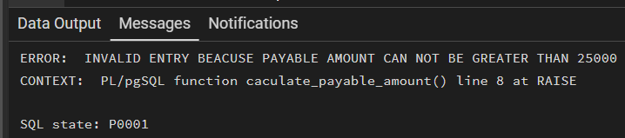
-- INSERT INVALID RECORD (SHOULD THROW ERROR)

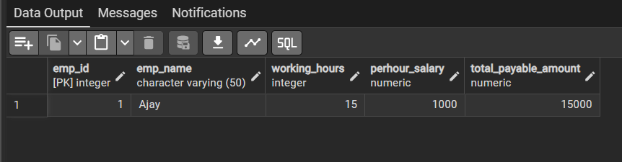
-- DISPLAY FINAL TABLE DATA

Learning Outcome:
- Understand how triggers automate database operations without manual intervention.
- Learn to implement trigger functions using PL/pgSQL.
- Gain practical experience in applying business rules and constraints using triggers.
- Understand the role of triggers in maintaining data consistency and validation.
- Develop the ability to design automated database systems for real-world applications.

